# Team 24 – Sprint 1 Testing Document

Sakshi Choudhary, Giorgi Khmaladze, Nick Litman, Mihir Somani, Conley Utz

User Story #8

**Test 1: Given that the user has filled all required fields of a listing, if the user inputs a price, then the price is correctly stored in the database**

Purpose: To meet acceptance criteria that the price is correctly stored in the database

Steps:

1. User properly inputs data in all required fields and also inputs valid input into the “Price” field

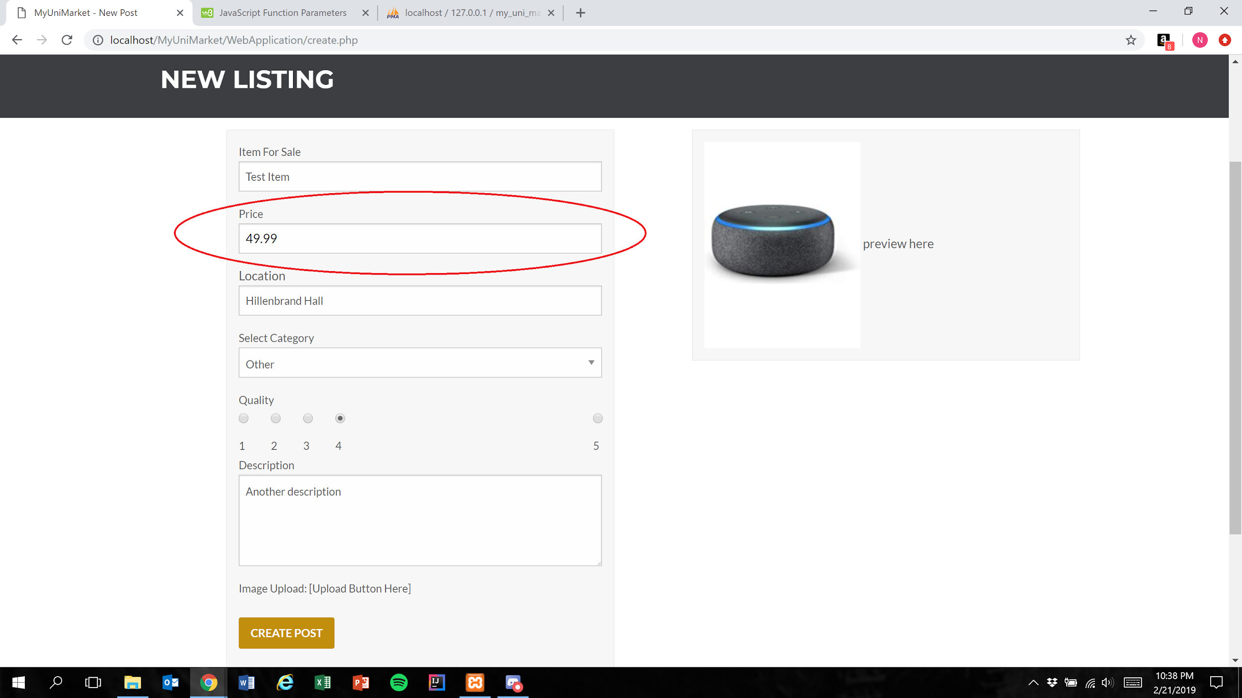

1. User presses the create post button

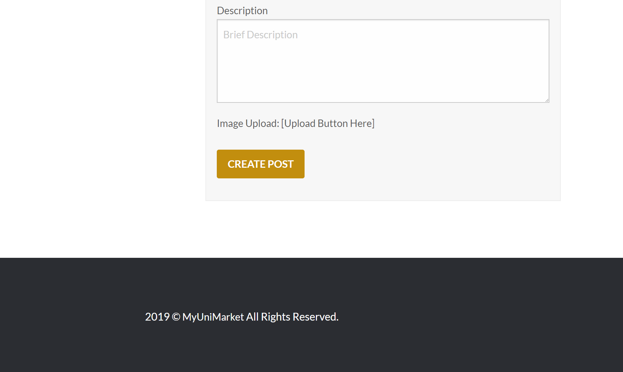

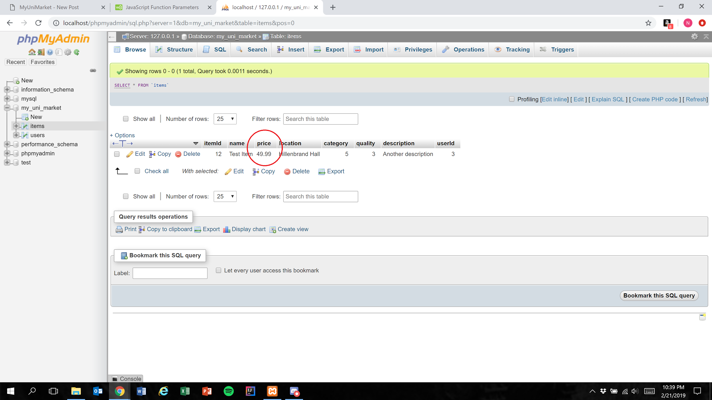

Expected Result: “Price” field is accurately represented in the database

Test Result: **PASSED**

**Test 2: Given that the user has filled all required fields of a listing, if the user attempts to input invalid characters into the “Price” field, then the input is not entered into the field**

Purpose: To meet the acceptance criteria that the user is unable to add invalid input to the “Price” field

Steps:

1. User properly inputs data in all required fields and attempts to include invalid input in the “Price” field
2. User is unable to type invalid input into the price field

Expected Result: The user is only able to type number characters and the “.” character

**NOTE:** Since the test involves characters *not* appearing in the “Price” field, screenshots will not be able to show the passing of this test

Test Result: **PASSED**